Name: Shreyas Joshi

SRN: 01FE20bcs145

School: CS

INFathon 3.0 at Informatica

Screenshot1:

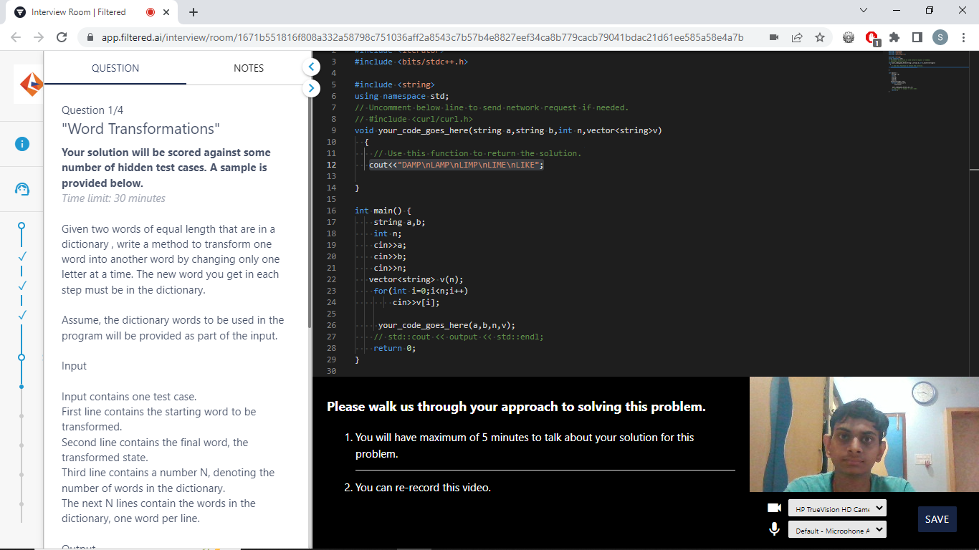

Screenshot2:

